Production Plans – Fireball!

[x] - Amount available/employed

# Proposal Synopsis

A 3D top down action party game for the PC, targeted towards casual gamers. The game contains a singular stage with baby dragons as main characters, and bunnies as the “enemies.” Power-ups can also be gained to enhance gameplay experience.

# Production Deliverables

A short fun playable game for casual players

* 2-4 players

# Feedback Response

* Bombs have become a power up as opposed to being the main mechanic
* The direction of the game’s atmosphere will remain cute and family-friendly

# 

# Team Members & Roles

**Members**

Designers: Glittika Gerdmanee (Nancy)  
Artists: Tirana Kilmister, Wing Him Choi

Programmer: Finn Perry

**Roles/Responsibilities**

Glittika Gerdmanee

* Audio & SFX
* UI Design & Art (Menu & Icons)
* Main Menu (Script & Art)
* Level Design (Greybox & Final)

Tirana Kilmister

* Concept Art (Character)
* Concept Art (Environment)
* Character Models
* Character Texturing
* UV Unwrapping

Wing Him Choi

* Animation
* Environment Models
* Environment Texturing
* Rigging
* UV Unwrapping

Finn Perry

* Game Mechanics
  + Character Controller
  + Critter [Enemy] Controller
  + Game Timer
  + Item Power Ups
  + Points System
* End Screen
  + Score & Player placement (1st, 2nd, 3rd, 4th)

# 

# Production Methodology

Project Management: Agile

* Every morning - Stand up Meeting - check up on:
  + What has been completed
  + What people are currently working on
* Start of every week - check Trello
  + Have a look at our priorities
  + What has been done and what needs to be in progress
* Weekly Communication with Client
  + Communicating with the client for feedback and ensure the project is up to their standards

**Software**

* Maya
* ZBrush
* Substance Painter
* Photoshop
* Unity3D
* GitHub Desktop
* Visual Studio

**Hardware**

* Wacom Intuos Pro Medium

**Communication**

* Discord
* Trello
* Google Drive

Discord is our team’s main form of communication from outside work hours

GitHub and Google Drive will hold the project and documents respectively

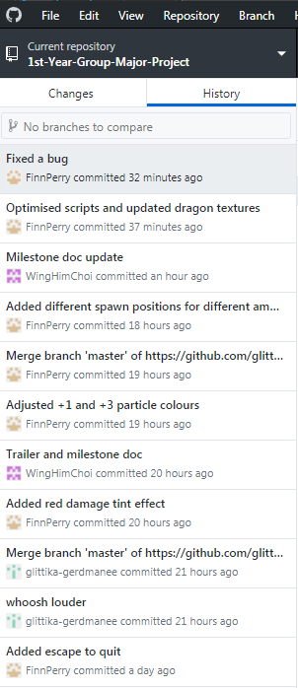

Trello is how our team manages the progression and upkeep of the project

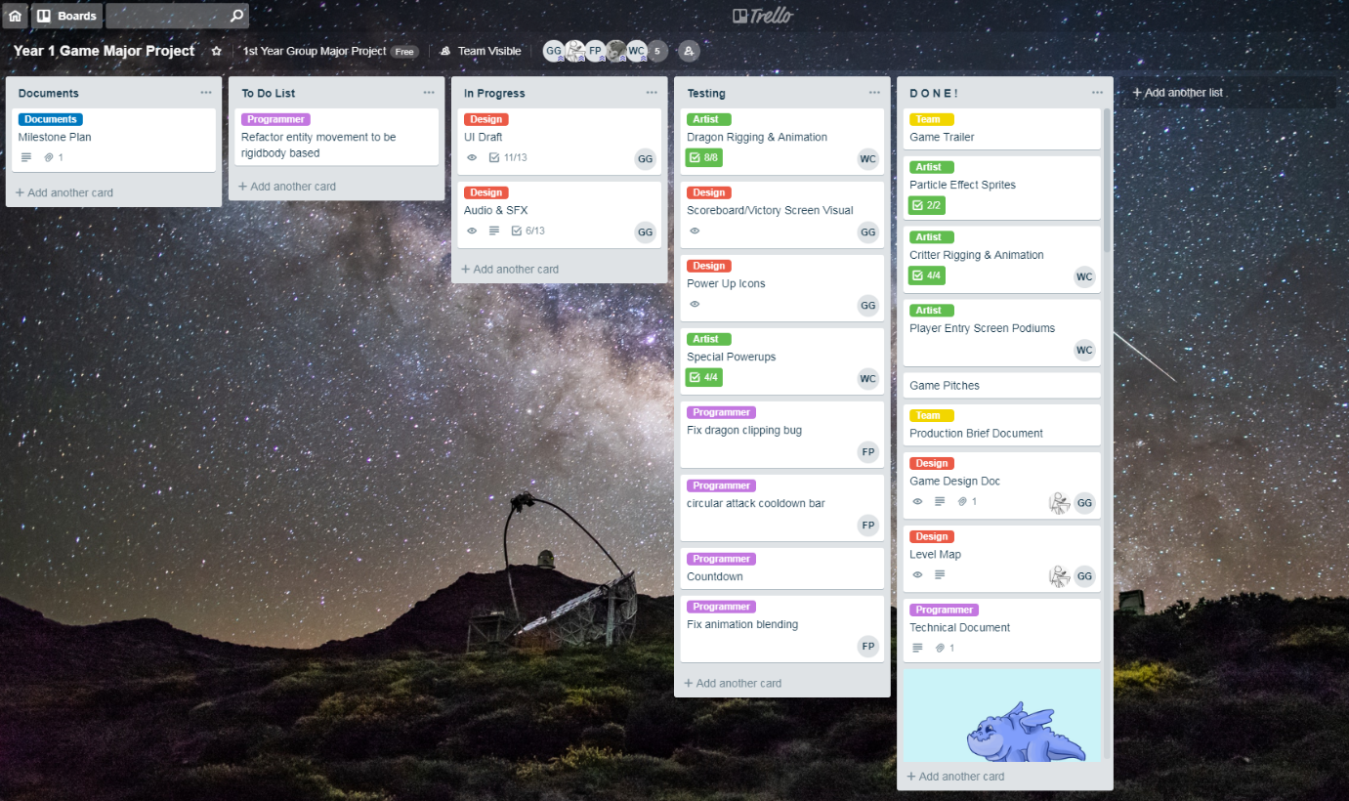

# Production Asset List

## Art

|  |  |  |
| --- | --- | --- |
| **Asset** | **Description** | **Polycount** |
| Bomb | Attainable Power up | 50 - 500 |
| Bomb Texture | PBR Texture | N/A |
| Bunny Critter Anim | Animation hop movement for critter | N/A |
| Bunny Critter | [Forest Arena] - main destroyable enemy | 500 - 1,000 |
| Bunny Texture | Hand-painted texture - 2 colour variations | N/A |
| Dragon Anim Attack | Animation attack action fro dragon | N/A |
| Dragon Anim Move | Animation movement for dragon | N/A |
| Dragon Char | A Playable Character | 500 - 1,000 |
| Dragon Textures [4] | Hand-painted textures - 4 colour variations | N/A |
| Environmental Textures | PBR Textures for   * Ground * Tree * Rocks | N/A |
| Rock 01-06 | Variety of rocks | 50 - 500 |
| Tree 01 | Fir tree, main tree for [Forest Arena] | 50 - 500 |
| Tree 02 | Curved tree, two main bunches of leaves | 50 - 500 |
| Tree 03 | Palm tree for [Forest Arena] and/or [Beach Arena] | 50 - 500 |
| Power Up Randomizer | Model for Power Up indicator |  |

# 

# Programming

|  |  |
| --- | --- |
| **Scripts** | **Description** |
| Critter Controller | Enemy controller   * Health * Movement * Random spawn * Point allocation (one enemy being worth more than another) |
| Dragon Controller | Player movement controller   * Attack * Health * Dash * Stunned (when health is depleted) |
| End Screen | Victory screen display with score and 1st, 2nd, 3rd, 4th player placement |
| Item Power Ups | * Bomb * Drop Rate * Freeze * Flame Cone (Widen range) * Piercing Flame (Across arena) * Shot Interval (Faster shots/less cooldown) |
| Level Selection | Chooses and loads a stage |
| Multi Controller | Allow for multiple players to move individually |
| Options Menu | * Brightness * Fullscreen/Windowed * Volume (Music/SFX) |
| Timer | Countdown timer until game ends |
| Particles | * Spawn/Despawn particles upon attack/power up usage |
| Points System | * Points gained per kill * Points display upon victory screen |

# 

# UI

|  |  |
| --- | --- |
| **UI** | **Description** |
| Button Controls | ‘A’ Button, R Trigger/Bumper |
| Background UI | Scrolling background design on start up menu |
| Font | Stylized Font |
| Menu Buttons | * Start Up Menu * Back buttons |
| Menu Title | Title of Game upon start up |
| Player Controller | Number indicator of which player is what controller |
| Player Display | (Updated version of Health bar) Health bar, Dash cooldown, attack cooldown, player colour indication (which player is who) |
| Power Up Icons | Icons per power up to display when collected in game battle |

# Audio

|  |  |
| --- | --- |
| **Sounds** | **Description** |
| BGM - Arena | Music during game battle - bouncy, cute, happy |
| BGM - Main Menu | Music upon game start up |
| Bomb Explosion | After bomb power up is activated |
| Button Confirm | When an action on the menu is confirmed |
| Button Move | When player switches between buttons on menu |
| Dash | Either a squeaky or whoosh sound when player dashes |
| Death - Critter | When player kills a critter - rabbit squeal |
| Fireball | When a player attacks with any form of fire |
| Freeze Dispensed | When a player is frozen by Freeze Power Up |
| Power Up Collected | When power up is picked up |
| Power Up Dispensed | When power up is activated |
| Roar | When stunned, winner on victory screen - babyish, squeaky and cutesy |
| Victory Fanfare | After a round ends, plays on Victory/Score screen - upbeat, cheery and short |

# Milestone Schedule

# 

# Budget

Project will approximately run for 2 months - all totals is equal to the payment of 2 months.  
However none of these payments will take place as all licensing and hardware is under student license

**Monthly Salary Total**

Entry Level Game Artist [2] - $4583.33 per person

Per month: 4583.33 x 2 = $9,166.67

Per person: 9,166.67 x 2 = $18,333.34

Entry Level Video Game Designer [2] - $5,617.25 per person

Per month: 5,617.25 x 2 = $11,234.50

Per person: 11,234.50 x 2 = $22,469

Game Programmer [1] - $8,408.70 per person

Per month: 8408.70 x 2 = $16,817.40

**Software Costs**

AutoDesk Maya License - $265 per month

Total (2 months): $530

Substance Painter Indie License - $19.90 per month

Total (2 months): $39.80

Adobe Photoshop - $44 per month

Per month: 44 x 2 = 88

Per person: 88 x 2 = 176

ZBrush (Multi-user) - $1,480 per person

Per person: $1,480 x 2 = $2960

**Hardware Costs**

Wacom Intuos Pro Medium [2] - $450 per tablet

Total: $900

# Risk Management

**Risk Matrix**

The following table maps the Likelihood x Severity to give a Risk Value

|  |  |  |  |  |  |
| --- | --- | --- | --- | --- | --- |
| **Severity / Likelihood** | **Minor (1)** | **Moderate (2)** | **Major (3)** | **Extreme (4)** | **Terminal (5)** |
| **Certain (5)** | **5** | **10** | **15** | **20** | **25** |
| **Likely (4)** | **4** | **8** | **12** | **16** | **20** |
| **Possible (3)** | **3** | **6** | **9** | **12** | **15** |
| **Unlikely (2)** | **2** | **4** | **6** | **8** | **10** |
| **Remote (1)** | **1** | **2** | **3** | **4** | **5** |

**Risk Banding**

High-Risk = 18-25

Moderate Risk = 12-17

Low-Risk = 5-11

No Risk = 1-4

**TEAM MEMBER ABSENCE**

* **Description:** Team member not always being available to work due to illness, work, or any other external reason
* **Likelihood:** Possible (3)
* **Severity:** Moderate (2)
* **Total Risk:** 6 – Low-Risk
* **Solution:** Maintain a communication with the absent team member to manage scheduling of work (re-prioritizing, what work can be done by a deadline, and from their current location)

**BROKEN/MISSING LEVEL**

* **Description:** Level missing completely due to some overriding in GitHub
* **Likelihood:** Possible (3)
* **Severity:** Extreme (4)
* **Total Risk:** 12 – Moderate Risk
* **Solution:** Ensure each major update is pushed into source control (GitHub) to keep track of various versions of the game – revert to last successful update/version

**UNDECIDED DIRECTION**

* **Description:** Indecisiveness about direction of game
* **Likelihood:** Possible (3)
* **Severity:** Minor (1)
* **Total Risk:** 3 – No Risk
* **Solution:** Sat down to discuss priorities and direction for the game, art style and visual narrative

**(ARENA) LEVEL DESIGN OVERSCOPE**

* **Description:** Overscoped amount of levels that could be created within the time frame
* **Likelihood:** Certain (5)
* **Severity:** Major (3)
* **Total Risk:** 15 – Moderate Risk
* **Solution:** Discussed changes to arena and ultimately decided to remove 3 out of the 4 arenas to solely focus on 1 arena